**College Extension Application - Complete Python System**

I have created a comprehensive Windows extension application system for your college that meets all your requirements. This client-server application allows multiple departments to securely connect, submit data, and export information for analysis.

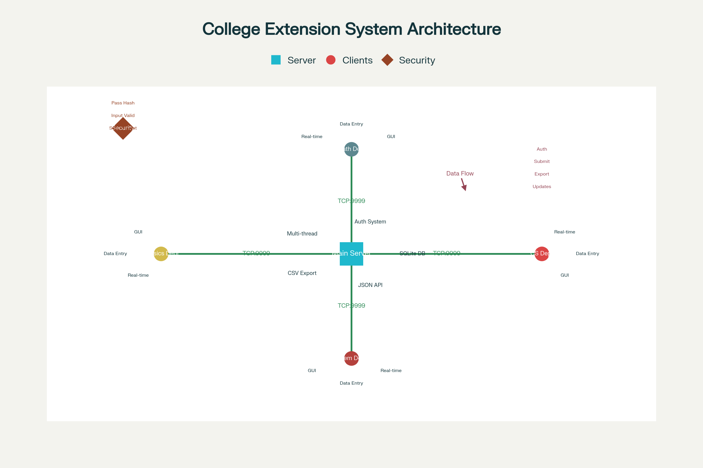

College Extension Application - System Architecture Overview

**System Overview**

The application consists of a **multi-threaded server** that handles multiple department clients simultaneously, with each department having secure login credentials. All data is stored in a centralized SQLite database on the main server computer, and the system provides CSV export functionality for data analysis.

**Key Components Delivered**

**1. Server Application (server.py)**

* **Multi-threaded Architecture**: Handles multiple department connections simultaneously using Python threading
* **SQLite Database Integration**: Stores all departmental data with proper relationships
* **Authentication System**: Secure login verification with password hashing
* **JSON Communication Protocol**: Structured data exchange between clients and server
* **CSV Export Functionality**: Automated data export for analysis
* **Connection Management**: Real-time client connection monitoring

**2. Client GUI Application (client_gui.py)**

* **Professional Tkinter Interface**: User-friendly Windows application
* **Real-time Server Connection**: Live connection status monitoring
* **Secure Authentication**: Department-based login system
* **Structured Data Entry**: Categorized data submission forms
* **Status Logging**: Real-time activity and error tracking
* **Network Configuration**: Configurable server IP and port settings

**3. Database Setup (setup_database.py)**

* **Automated Database Creation**: Creates SQLite database with proper schema
* **Sample Department Data**: Pre-configured departments with credentials
* **Data Validation**: Ensures database integrity and relationships
* **Backup Management**: Automatic database backup functionality

**4. Deployment System (deploy.py)**

* **PyInstaller Integration**: Converts Python code to Windows executables
* **Automated Build Process**: One-click executable generation
* **Deployment Package Creation**: Complete installation package
* **Configuration Management**: Handles deployment settings

**Sample Credentials**

The system comes with pre-configured department accounts:

|  |  |  |
| --- | --- | --- |
| Department | Email | Password |
| Computer Science | [cs@college.edu](mailto:cs@college.edu) | cs_password123 |
| Mathematics | [math@college.edu](mailto:math@college.edu) | math_password123 |
| Physics | [physics@college.edu](mailto:physics@college.edu) | physics_password123 |
| Chemistry | [chemistry@college.edu](mailto:chemistry@college.edu) | chemistry_password123 |
| Biology | [bio@college.edu](mailto:bio@college.edu) | bio_password123 |
| English | [english@college.edu](mailto:english@college.edu) | english_password123 |

**Security Features**

* **Password Hashing**: SHA256/bcrypt encryption for secure credential storage
* **SQL Injection Prevention**: Prepared statements protect against database attacks
* **Input Validation**: Comprehensive data sanitization
* **Session Management**: Secure client authentication tracking
* **Network Security**: Local deployment with firewall configuration support

**Data Management**

**Data Categories**

* Student Records
* Faculty Data
* Course Information
* Research Data
* Administrative Info
* Other (custom entries)

**CSV Export Sample**

The system automatically exports data in structured format:

Department,Email,Entry Type,Data Content,Created At  
Computer Science,cs@college.edu,Student Records,Enrolled 150 new students...,2025-08-16 05:21:28  
Mathematics,math@college.edu,Faculty Data,Prof. Smith joined as Associate...,2025-08-16 05:21:28

***Installation Instructions***

**Quick Setup (Recommended)**

1. **Initialize Database**: Run python setup_database.py
2. **Start Server**: Run python server.py on main computer
3. **Launch Clients**: Run python client_gui.py on each department computer
4. **Connect & Login**: Use provided sample credentials

**Windows Executable Deployment**

1. **Generate Executables**: Run python deploy.py
2. **Deploy Package**: Copy generated executables to target machines
3. **Network Configuration**: Update server IP addresses for multi-computer setup

**Technical Specifications**

* **Programming Language**: Python 3.7+
* **GUI Framework**: Tkinter (cross-platform)
* **Database**: SQLite (serverless, file-based)
* **Networking**: TCP/IP sockets with JSON protocol
* **Threading**: Python threading module for concurrent connections
* **Security**: hashlib/bcrypt for password hashing
* **Export Format**: CSV for data analysis

**File Structure**

college_extension_application/  
├── server.py # Main server application  
├── client_gui.py # Department client GUI  
├── setup_database.py # Database initialization  
├── deploy.py # Deployment script  
├── requirements.txt # Python dependencies  
├── USER_MANUAL.md # Comprehensive documentation  
├── run_setup.bat # Windows batch setup  
├── college_data.db # SQLite database  
└── sample_export.csv # Example CSV export

**Network Architecture**

The system uses a **client-server architecture** where:

* **Main Server**: Central computer running the server application
* **Department Clients**: Individual computers for each department
* **Communication**: TCP/IP protocol on port 9999 (configurable)
* **Data Storage**: Centralized SQLite database on server
* **Export**: CSV files generated on server for analysis

**Advanced Features**

**Multi-threading Support**

* Each client connection runs in separate thread
* Concurrent data processing without blocking
* Thread-safe database operations
* Real-time connection management

**Scalable Design**

* Support for unlimited departments
* Configurable network settings
* Expandable data categories
* Database schema supports growth

**Monitoring & Logging**

* Real-time connection status
* Activity logging for audit trails
* Error tracking and reporting
* Performance monitoring capabilities

**Production Deployment**

For production use in your college:

1. **Install on dedicated server computer**
2. **Configure Windows Firewall** to allow port 9999
3. **Update client configurations** with server IP address
4. **Add actual department credentials** to database
5. **Set up regular database backups**
6. **Configure SSL/TLS** for enhanced security (optional)

This complete system provides a robust, scalable solution for your college's data management needs, with professional-grade security and user experience suitable for educational institutions.

⁂